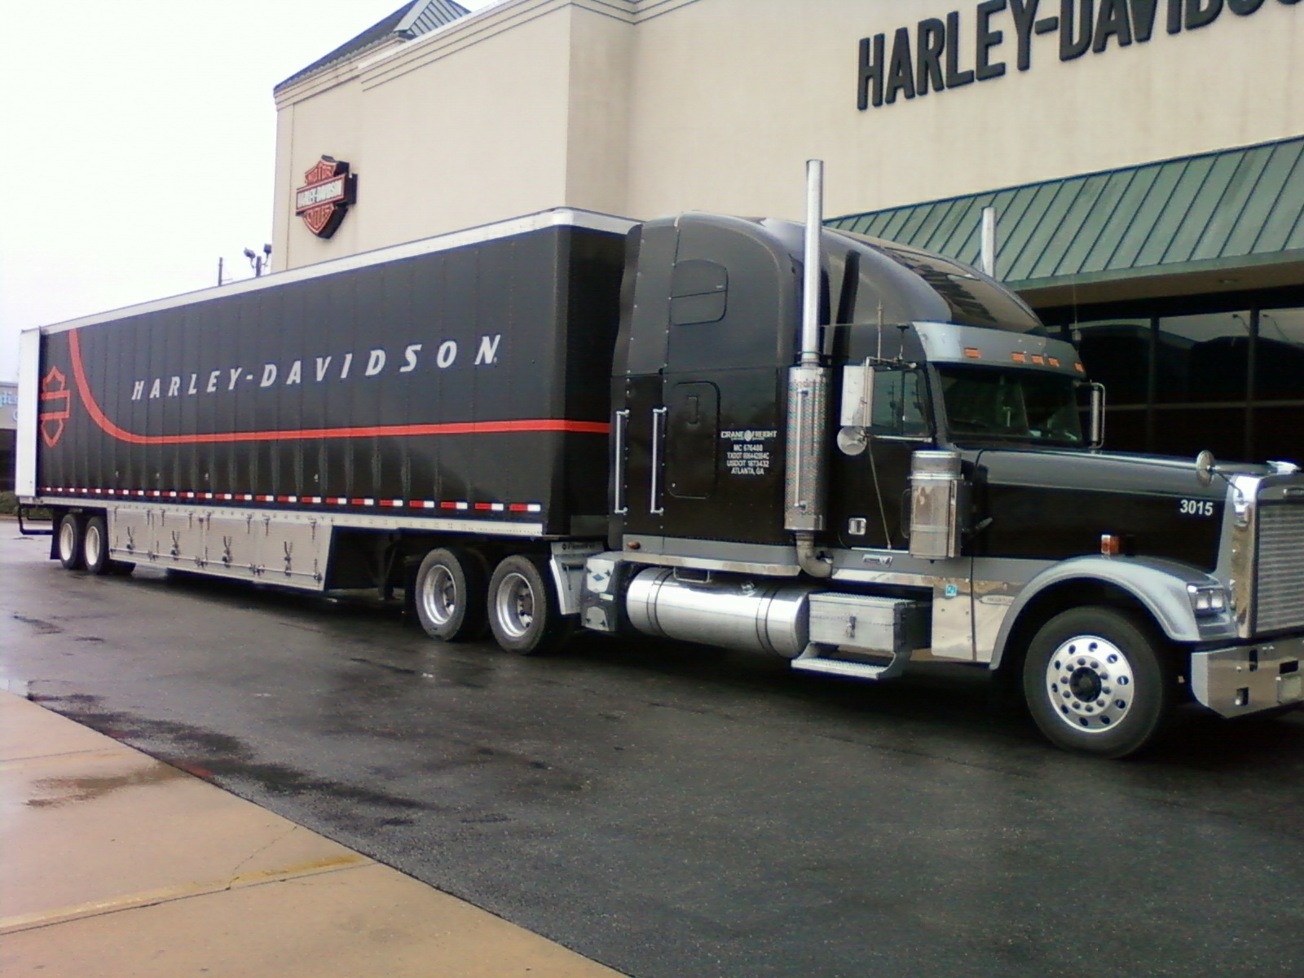

2015
FREIGHT ROUTING GUIDE

INTRODUCTION

This guide has been prepared to provide a greater understanding and means to effectively manage corporate wide transportation expense. Because transportation costs have a direct relationship with the cost of our products, the Harley-Davidson Global Transportation department has negotiated service and rate agreements with numerous transportation companies to maximize service and value throughout the Harley-Davidson supply chain.

By following the routing instructions contained in this guide, we will assure the most efficient flow of materials to/from our suppliers and delivery of products to our dealers. To minimize and control transportation expense, one must follow these routing instructions for all non-motorcycle shipments.

Thank You

Harley-Davidson Motor Company

TABLE OF CONTENTS

Definition of freight terms -------------------------------- 4 - 8
Tracing shipments ------------------------------------------ 9 - 10
Domestic transportation motorcycle delivery ---------------- 11
International ocean or air shipments ----------------------- 12
Customs compliance & product classification ---------------- 12
Non-Recurring inbound only one shipment from any supplier--- 13
Recurring inbound shipment from any supplier---------------- 14
LTL Routing Guide Matrix ------------------------------------14
Outbound Shipment from Any H-D Site------------------------- 15

DEFINITION OF TERMS

AIR BILL
A non-negotiable document by which an airline acknowledges receipt of freight and contracts for its movement. In many cases the air bill also serves as the invoices for freight charges.

AIR FREIGHT
Movement of merchandise via airplane.

BILL OF LADING
A non-negotiable document by which a surface transportation service acknowledges receipt of freight and contracts for its movements.

BREAKBULK
A large terminal that separates composite loads into individual shipments and then routes them to different destinations. Also called break or hub or distribution center.

CARRIER
An individual or corporation engaged in the business of transportation goods via air, surface, rail or water.

CARTAGE
The process of moving freight from a supplier to a consolidation or from a carrier to a receiver via carts, hand truck or motor truck.

CLAIM
A demand made upon a transportation service for payment due to of loss, damage, or overcharge.

COLLECT SHIPMENT
A shipment for which freight charges are paid to a transportation service by the consignee.

COMMERCIAL ZONE
Areas defined by the Interstate Commerce Commission and state regulatory commissions that are not subject to publish rates and regulations. It also defines the area under F.O.B terms where freight should be delivered free to the consolidators.

COMMON CARRIER
A transportation service engaged in the business of transportation persons or goods for
Compensation and for all persons impartially.

DEFINITION OF TERMS, cont.

CONCEALED DAMAGE
Damage to the contents of a package that is in good order externally.

CONNECTING CARRIER
One of two or more carriers participating in the movement of a shipment from origin to destination.

CONSIGNEE
The party to whom goods are shipped.

CONSIGNOR
The party by whom goods are shipped.

CONSOLIDATING
The practices of having suppliers deliver shipments to an agent for the purpose of combining their shipments into carload, truckload, or volume air shipments.

CONTRACT CARRIER
A transportation service engaged in the business of transporting persons or goods for compensation while under contract to a specific shipper(s).

DUNNAGE
The material used to protect or support freight in or on trucks.

DUTY
A tax levied by a government on the import, export, use or consumption of goods.

ENTRY (CUSTOMS)
A statement of the kinds, quantities and values of goods imported together with duties due, if any, and declared before a customs officer or other designated officer.

EXPEDITE
To arrange with transportation service for rapid delivery of a shipment.

EXPORT
Any traffic having subsequent movement to a foreign country.

F.O.B.
A term meaning “Free On Board” (See terms of Sale)

DEFINITION OF TERMS, cont.

FREE ASTRAY
The portion of a shipment delivered without charge subsequent to the time of original shipment delivery.

FREIGHT ALL KINDS (FAK)
The abbreviation applied to a pooling of different commodities for simplification of rating or pricing.

FREIGHT ASTRAY
A shipment miscarried or unloaded at the wrong terminal, billed and forwarded to the correct terminal, free of charges, because of being astray, hence the term “freight astray”.

IMPORT
Any traffic having prior movement from a foreign country.

INTERLINE
Freight moving from origin to destination via two or more transportation services.

INTRASTATE SHIPMENTS
Transportation of shipments within a state.

INTERSTATE SHIPMENTS
Transportation of shipments between states.

LESS THAN TRUCKLOAD (LTL)
The quantity of freight less than that required for the application of a truckload rate.

NATIONAL MOTOR FREIGHT CLASSIFICATION (NMFC)
A publication for motor carriers containing rules, descriptions and ratings on all
Commodities moving in commerce.

NESTED
Packed one within another.

ON HAND
Freight which cannot be delivered by carrier and is held awaiting disposition.

DEFINITION OF TERMS, cont.

OVERAGE
Excess freight over the quantity believed to have been shipped, or more than the quantity shown on the shipping document.

O S & D (Over, Short & Damaged)
A term used to describe a shipment that has been damaged or lost in transit or arrives with more containers than originally shipped.

PACKING LIST
A detailed listing of the contents of a shipment.

PICK-UP
The collection of goods at consignor by the transportation service.

POINT OF ORIGIN
The city from which merchandise is shipped.

PREPAID
A term denoting transportation charges are to be paid by the consignor.

PRO-NUMBER
Carrier’s identification number assigned to a freight bill covering a shipment of merchandise.

RECONSIGNMENT
A change in the delivery address that takes place after the shipment has been tendered to the transportation service.

REFUSED FREIGHT
Freight which the consignee or owner refused to accept.

ROUTING
Instructions to consignor on proper carrier to use in shipping merchandise.

SHIPPERS LOAD AND COUNT
Denotes that the contents of a car or trailer were loaded and counted by the shipper and not checked or verified by the transportation line.

STORAGE
Holding of freight by the carrier at the owner’s risk.

STORAGE CHARGE
Charge assessed by carrier for holding freight in storage.

DEFINITION OF TERMS, cont.

TARIFF
A schedule of rates, rules and regulations published by a carrier or on behalf of a carrier by an agency.

TRACE
To track the movement of a shipment and determine its location.

TRUCKLOAD (TL)
Quantity of freight required to fill a truck. When used in connection with freight rates, the quantity of freight necessary to qualify shipments for a truckload rate.

TRACING SHIPMENTS

To trace any shipment you must have the carrier’s PRO number or Airbill number. Most carriers maintain Internet web sites that can be used for tracking shipments.

To track a shipment through your site transportation contact, the following information is required:

1. The carrier PRO number or Airbill number. If you have this information, nothing else is needed.
2. Date shipped
3. Shipper Name
4. Origin city, state or zip code
5. Destination
6. Number of pieces and total weight of shipment
7. Bill of lading identification number

Most of the above information may be obtained from the ASN sent from the supplier. If no ASN is available, the information can be obtained from the supplier.

You may trace your own shipments via the Internet using or by calling the carrier once you have the correct PRO or tracking number:

FOR SHIPMENT TRACKING

Estes Express
www.estes-express.com

Pitt-Ohio
www.pittohio.com

ABF
http://www.abfs.com/

A Duie Pyle
www.aduiepyle.com

Nebraska Transport
www.nebt.com

AAA Cooper Transportation
www.aaacooper.com

Lakeville Motor Express
www.lakevillemotor.com

Expedited Freight Systems
www.expedited.org

Conway
http://www.con-way.com/en

Dayton Freight Lines
http://www.daytonfreight.com/

USF Holland
http://www.hollandregional.com/index.shtml

YRC Freight
http://www.yrc.com/

Small Package - UPS
www.ups.com/tracking/tracking/
Call 800.877.1497

For tracking issues and further follow up please contact the Transportation Control Tower 414.501.1546 or 877.612.8044

SPECIAL REQUEST FOR TRANSPORTATION
DOMESTIC MOTORCYCLE DELIVERY

Juneau
- Gary Chatham Office – 414.343.7807 or Cell- 262.617.8301

Provide the following information:
1. Complete origin address with contact names and telephone numbers.
2. Complete destination address with contact names and telephone numbers.
3. Number of pieces being shipped.
4. Weight of each piece being shipped.
5. Dimensions (height, width, length) of each piece being shipped.
6. Appropriate site paper work to ship or receive.
7. Realistic time needed at destination. The difference between a few hours may mean thousands of dollars less in cost.
8. Purchase Order number and account code for charging shipping cost.

INTERNATIONAL OCEAN OR AIR SHIPMENTS

Motorcycles

- Import and Export of Motorcycles
Tracy Vogt Office – 414.343.8297 or Cell 262.378.0827

Parts and Accessories

-Import of Parts and Accessories
Tracy Vogt Office – 414.343.8297 or Cell 262.378.0827

-Exports of Parts and Accessories to:

Japan, Asia/Pac, Australia, New Zealand and Europe:
Tracy Vogt Office – 414.343.8297 or Cell 262.378.0827

Latin America:
Tracy Vogt Office – 414.343.8297 or Cell 262.378.0827

Canada:
Tracy Vogt Office – 414.343.8297 or Cell 262.378.0827

International Customs Compliance & Product Classification

If you have any questions or problems regarding Customs procedures, import or export compliance, contact
Dina Swanson Office – 414.343.7265 or Cell 414.248.3184
Bill Taylor Office – 717.852.6877 or Cell 717.818.1635

All commodities shipped internationally require a Harmonized Commodity Code (HCC) number. Previously classified items show a HCC in the AS-400 database. If this information is missing or otherwise unavailable please contact
Bill Taylor Office – 717.852.6877 or Cell 717.818.1635

NON RECURRING INBOUND, ONLY ONE
SHIPMENT FROM ANY SUPPLIER

- Please work with your Harley-Davidson Supply Chain Analyst to determine the optimal ship method. This will ensure shipment meets the service requirements set forth by Harley-Davidson.

- For shipments packaged, not on skids, less than 150 pounds, and have a combined length and girth 130” or less and maximum length of 108”.

Ship United Parcel Service (UPS) – Collect
See contact list on page 15 to obtain UPS account number

- All shipments exceeding weight stated above but less than 10,000 pounds and fitting on 8 pallets or less ship as follows:

For freight shipping from listed state to any H-D plant please see the LTL routing guide listed on page 14

- If the shipment is greater than 10,000 pounds contact your local traffic coordinator to set up a TL movement.
(See list on next page 15)

RECURRING INBOUND, MORE THAN ONE,
SHIPMENT FROM ANY SUPPLIER

When shipping on a recurring basis, contact the assigned Harley-Davidson Supply Chain Analyst from the site that will be receiving the material. This will accomplish several things:

- Detail all requirements for the orders.
- Ensure the most effective, least cost corporate approved carrier is used.
- Have a freight routing letter issued to the supplier, with a copy for your files to maintain ISO compliance.
- Have the correct routing on your purchase order.
- Site specific electronic files will have correct routings.

NOTICE: THIRD PARTY FREIGHT POLICY:

Harley-Davidson Motor Company (HDMC) will only pay freight invoices for OE material shipped into or out of its facilities, no third party freight will be paid. Third party freight is defined as shipments tendered to another supplier of non-Harley business entity, for which HDMC is required to pay the actual freight invoice. In the event HDMC
has provided written agreement prior to shipment to absorb the cost of transportation, this expense is to be either added onto your product invoice to HDMC or included in the piece price itself. No exception to this policy will be made; this change was effective January 1, 2005.

Printable Version – Harley-Davidson LTL Routing Guide Matrix

OUTBOUND SHIPMENT
FROM ANY H-D SITE

When shipping outbound freight contact the assigned site traffic personnel or use the established site shipping procedures. Each site has an ISO shipping request form found at the following local locations:

Site | Type Process | Contact | Telephone
H-D Greenwood DC | Manual | Dan Williams | 414.501.1541
 |  | Steve Swendrowski | 414.343.7554
H-D Juneau Ave | Manual | Steve Swendrowski | 414.343.7554
 |  | Dan Williams | 414.501.1541
H-D Kansas City | Manual | David Scott | 816.270.8001
 |  | Tony Curttright | 816.270.8429
H-D Pilgrim Road | Manual | Anthony Pryal | 414.375.6359
 |  | Kevin Latour | 414.375.6325
H-D PDC | Manual | Steve Swendrowski | 414.343.7554
 |  | Anthony Pryal | 414.375.6359
H-D Tomahawk | Manual | Anthony Pryal | 414.375.6359
 |  | Kevin Latour | 414.375.6325
H-D York | Manual | Jeremy Roskovensky | 717.852.6510
 |  | Mark Longnecker | 717.659.6139
 |  | Roberta Smith | 717.858.3928

